STUDENT |  | GRADER | Total Score
 |  |  | Total Score
  I am submitting my own work, and I understand penalties will
  be assessed if I submit work for credit that is not my own.
   | Print Name |  | ID Number
   | Sign Name |  | Date
  # | Points | Score
  1 | 6
  2 | 28
  3 | 24
  4 | 16
  5 | 20
  6 | 9
 |  |  | Weeks late
 |  |  | Adjusted Score
 |  |  | Adjusted Score
  Estimated Work Hours
  1 | 2 | 3 | 4 | 5 | 6 | 7 | 8 | 9 | 10
  1 | 2 | 3 | 4 | 5 | 6 | 7 | 8 | 9 | 10
  Overall Weight
Adjusted Score:
Deduct 20% from score for each week late

Problem 1. Show the total transistor count and gate/input number for the circuits below. Then sketch equivalent circuits that use fewer transistors (hint: NAND)

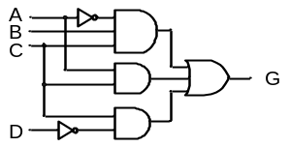
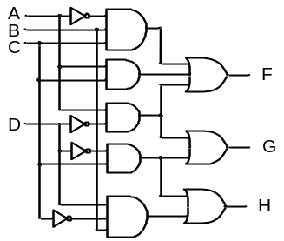
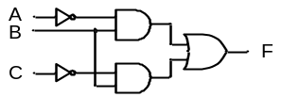

Problem 2. Find minimal equations for the systems shown.
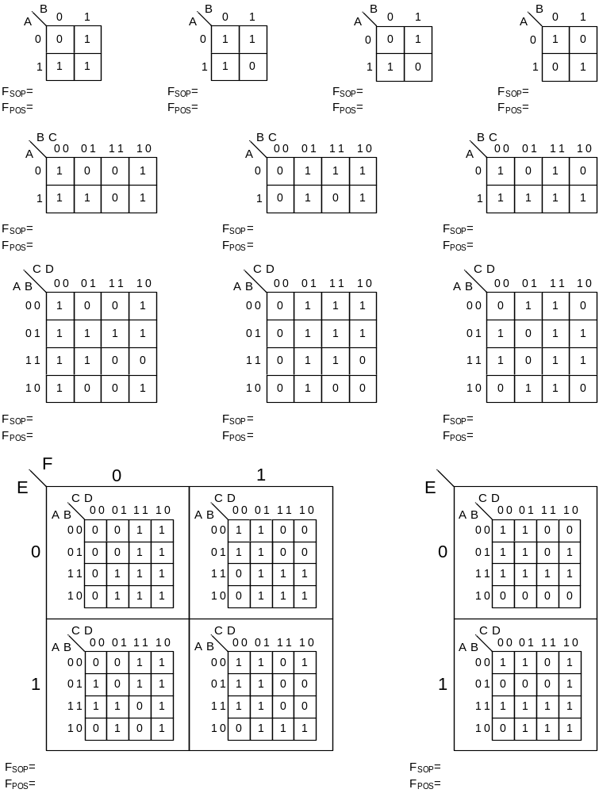
F = Σm(0, 1, 4, 5) G = ΠM(0, 1, 3, 4, 5, 7, 13, 15)

BC  A | 00 | 01 | 11 | 10
0
0
F
CD  AB | 00 | 01 | 11 | 10
00
01
11
10
F

F_{SOP} =

F_{POS} =

F_{SOP} =

F_{POS} =

Problem 3. Find minimal equations for the systems shown below. Circle the equation of the simplest form (SOP or POS), and circle both if they are equal.

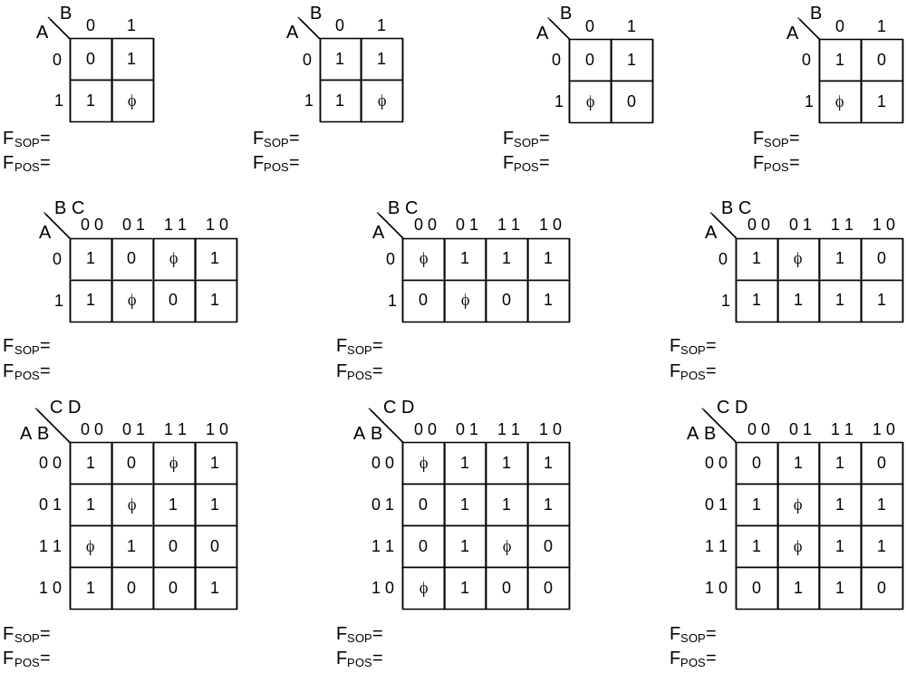
F = Σm(0, 1, 4, 5) + φ (2, 7) G = ΠM(0, 1, 4, 5, 7, 13, 15) + φ (2, 3, 11, 12, 14)

BC  A | 00 | 01 | 11 | 10
0
0
F
CD  AB | 00 | 01 | 11 | 10
00
01
11
10
F

F_{SOP} =

F_{POS} =

F_{SOP} =

F_{POS} =

Problem 4. Find minimal SOP and POS equations for the systems shown.

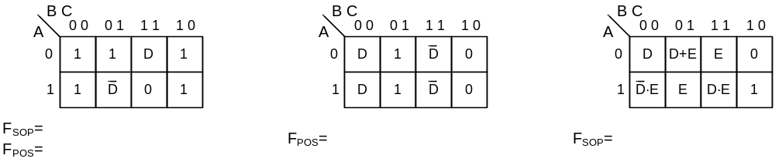

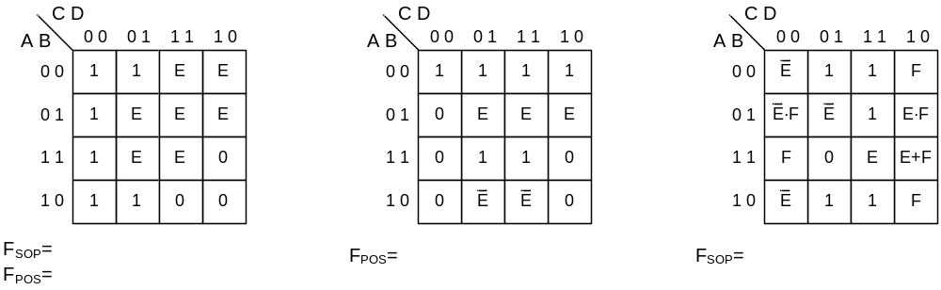

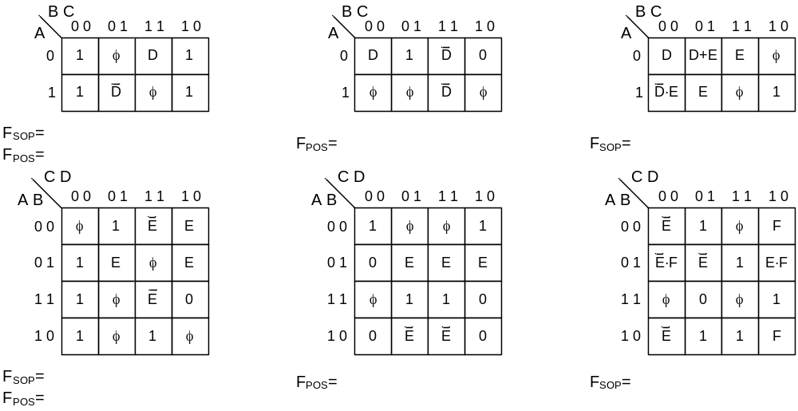

Problem 5. Find minimal SOP and POS equations for the systems shown.
F=Σm(0,2,7,9,10,11,14) + φ(4,5)
BC  A | 00 | 01 | 11 | 10
0
1
F

F_{SOP} =

F_{POS} =

F= Σm(0, 2, 3, 7, 8, 15) + φ (4, 5, 12, 13) (Map and loop this equation in all three maps below)

CD  AB | 00 | 01 | 11 | 10
00
01
11
10
F
BC  A | 00 | 01 | 11 | 10
0
0
F
C  B | 0 | 1
0
1
F

F_{SOP} =

F_{POS} =
Y = Σ m (0,2,4,8,9,10,14,22,31) + φ(6,7,12,13,24,25)

CD  AB | 00 | 01 | 11 | 10
00
01
11
10
Y
F_{SOP} =

F_{POS} =

Y = Π M (0,2,4,8,9,10,14,22,31) + φ(6,7,12,13,24,25)
CD  AB | 00 | 01 | 11 | 10
00
01
11
10
Y
F_{SOP} =

F_{POS} =

Problem 6. Find global minimum circuits for the following three logic signal outputs that are all functions of the same three inputs. Show all work.

F1 = Σ m (0, 3, 4) F2 = Σ m (1, 6, 7) F3 = Σ m (0, 1, 3, 4)

